Db.php: Connection to database (onlinevotingsystem2).

Register.php: Enables user to register using unique credentials (username,password,email)

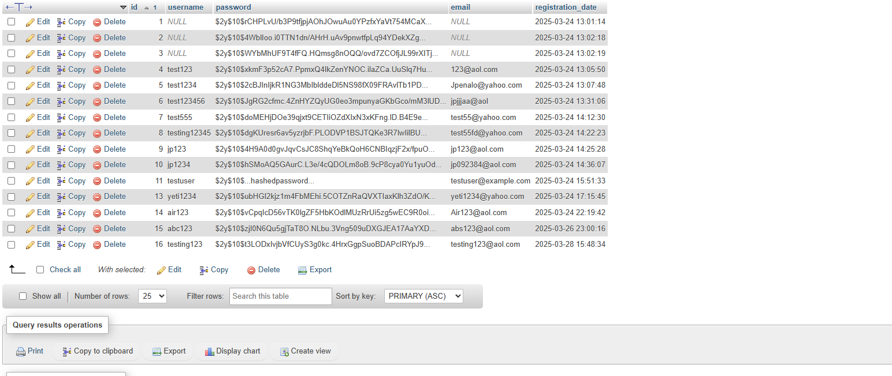

All registered user data is stored in the users table

Login.php : User login refers to data from users table to validate credentials in order to have access to vote.php

Vote.php: Users cast their vote; fetches data from votes table in the database to enforce one time voting policy; Records voting submissions. Using fetch() command to search for previous voting submissions

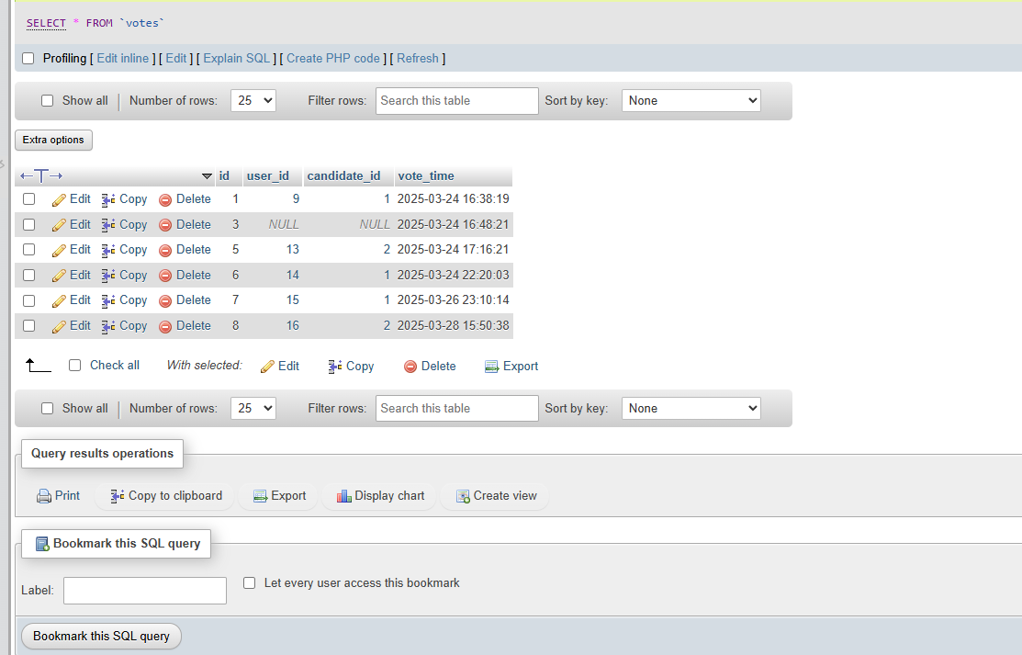

Results.php : Displays total votes for each candidate and each voting submission

